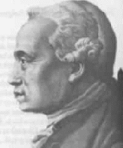
Kant

The Good Will and Duty
In the search for intrinsic ‘good’, Kant did not believe that any outcome was inherently good. Pleasure or happiness could result out of the most evil acts. He also did not believe in ‘good’ character traits, as ingenuity, intelligence, courage etc. could all be used for evil. In fact, he used the term good to describe the ‘good will’, by which he meant the resolve to act purely in accordance with one’s duty. He believed that, using reason, an individual could work out what one’s duty was.

Free Will, God and Immortality
If our actions are pre-determined and we merely bounce around like snooker-balls, we cannot be described as free and morality doesn’t apply to us. Kant could not prove that we are free – rather, he presumed that we could act morally, and for this to be the case we must be free. He also thought that it followed that there must be a God and life after death, otherwise morality would make no sense.

Synthetic A Priori
We do not follow predetermined laws. However, we must act according to some laws, otherwise our actions are random and without purpose. As a result, rational beings must determine for themselves a set of laws by which they will act.

These laws are not analytic (true by virtue of their meaning), but they cannot be determined through experience (a posteriori). Hume pointed this out when he said that you couldn’t move from an is (a synthetic statement about the world) to an ought (a statement about the way the world should be). The rational being has to determine the synthetic a priori – the substantive rules that can be applied prior to experience.

The Categorical Imperative – Universalisability
An imperative is a statement of what should be done. We have said before that Hume realised you can’t get a should statement out of an is statement. In other words, experience can only give us hypothetical imperatives (If you want to be healthy, then you should exercise and watch what you eat). A description of the way the world is cannot tell us the way we should act.

A Categorical Imperative is a should statement, but it is not based on experience, and doesn’t rely on a particular outcome. Rather, it logically precedes experience, or helps us make sense of experience. In another area of thinking, Kant showed that we must presume that time moves forwards – our mind imposes this on our experiences to make sense of them. We therefore could never demonstrate or prove this through experience.

It is like that with the categorical imperative: certain actions are logically inconsistent and would make no sense as universal laws, such as lying. As a result, ‘Do not lie’ is a categorical imperative. This understanding that our mind plays an active role in ordering and shaping our experience was revolutionary, and is Kant’s greatest achievement.

Kant states the categorical imperative as follows:

I ought never to act except in such a way that I can also will that my maxim should become a universal law.

Act as if the maxim of your action were to become by your will a universal law of nature.

The Categorical Imperative – Ends and means
A good will is one that acts in accordance with rationally-determined duty. No character trait or consequence is good in itself. However, as good is defined in terms of rationality, Kant argued that all rational beings were ends in themselves and should never be treated purely as a means to an end. He put this two different ways:

So act as to treat humanity, whether in your own person or in that of any other, in every case as an end in itself, never as means only.

So act as if you were through your maxims a law-making member of a kingdom of ends.

These latter statements of the Categorical Imperative are really an extension of the statements regarding universalisability – we hold laws if we would will that all other rational beings would also follow them. As a result, it would be contradictory for any rule to treat a rational being as a means to some greater end: there can be no greater end. Put another way, I cannot prescribe a rule that, if held by someone else, would result in my being treated merely as a means to end.

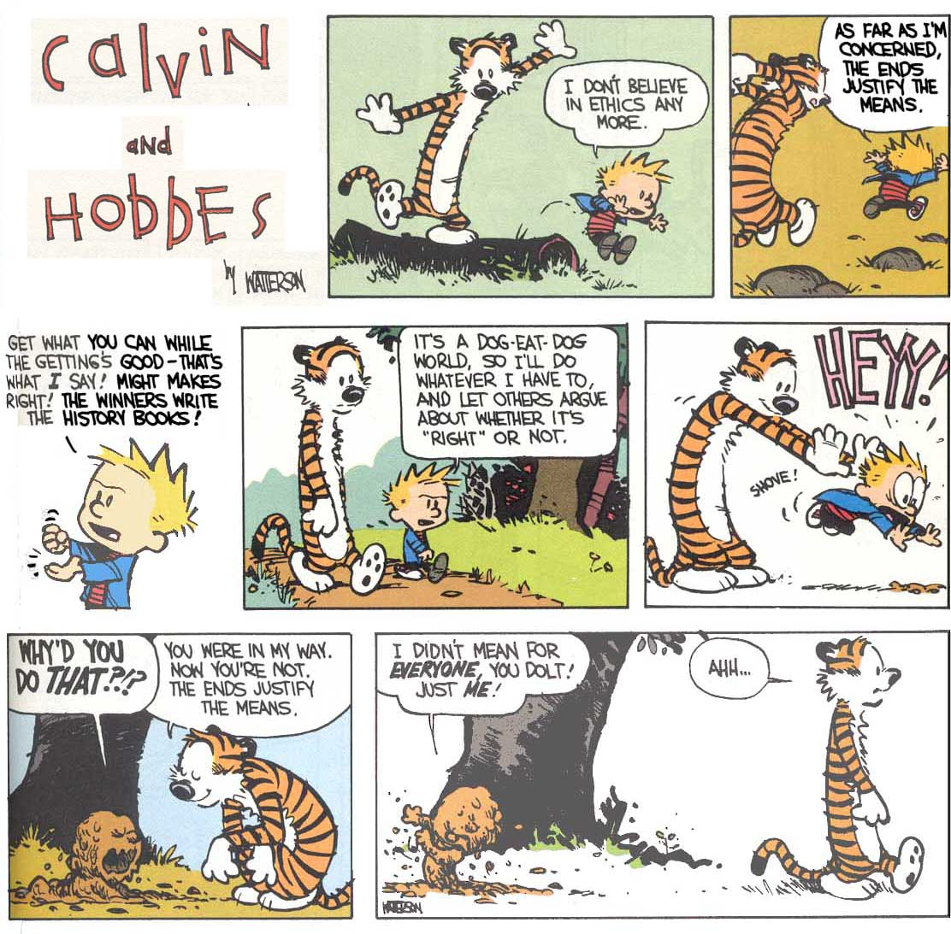

The categorical Imperative, stated four different ways above, could be seen as a rational justification for following the golden rule that is the cornerstone of Christian morals (as well as most other religions):

Love your neighbour as yourself.

Criticisms
All deontological (duty or rule-based) systems will have problems when two rules come into conflict. It is possible to have a third rule (Always tell the truth unless doing so endangers someone’s life), but this complicates the theory, resulting in rules with lots of clauses and sub-clauses (a little like our legal system).

There could also be literally millions of rules that are not self-contradictory but, if universalised, would seem absurd. Here Kant says that we should reject those rules which, if universalised, would produce a state of affairs utterly objectionable to all rational people. This suddenly looks less convincing than before – how can we tell what rational people would find objectionable? As with Utilitarianism, many philosophers prefer to adapt Kant’s theory rather than discard it completely.

