Some Non-cognitive Ethical Theories

Cultural Relativism
Ethics throws up some difficult issues. Should moral laws apply to all people in all societies? Many early Christian missionaries thought so, and there was much blood shed on the missionary field because indigenous people were seen as savages who did not know how to behave. Even in Australia today, the ‘white’ government exerts its moral authority over the Aborigines, making judgements about how society and family should be structured. Many Aboriginal children are taken away from their families because they are not receiving a ‘good’ upbringing.

As a result, Cultural Relativism seems an appropriate response:

‘Good’ means ‘socially approved’.
Pick out your moral principles by following what your society approves of.

Cultural relativism appears to be fairly logical at first glance. Throughout time and across the world, moral standards have changed. When I say ‘It is wrong to have more than one wife’, what I really mean is that it is not approved of in my society. Other societies have different customs and practices, so the cultural relativist is enlightened and tolerant, recognising that there are many different reasons for choosing how to behave. If we claim that our morality is absolute or objective, this is just an attempt to force others to agree with our views.
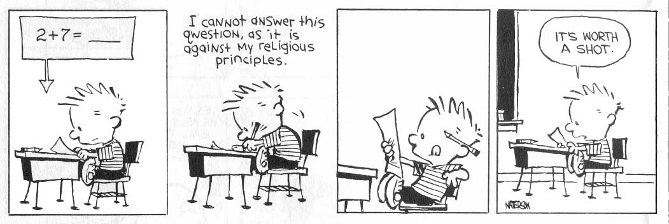

Harry Gensler (Ethics: a contemporary introduction) states the cultural relativist’s attack on objectivity as follows:
- morality is a product of culture
- cultures disagree widely about moral issues
- there is no clear way to resolve moral differences
Can you think of responses to these points?

Problems with Cultural Relativism
There are so many problems that CR is soon discarded by people who at first think it holds water. Firstly, it doesn’t allow you to question society’s norms. In asking whether slavery was right or wrong, you would merely be asking whether it was approved of in a certain society – if you challenged that society with the notion of equality, the cultural relativist would be forced to dismiss your arguments out of hand, because any position contrary to what society approves of is automatically wrong. Put another way, a cultural relativist living in a country where slavery was approved of would have to either agree that slavery was good, or disagree with cultural relativism.

Far from being the tolerant world view it had hoped to be, CR is inherently intolerant of minority views – any minority view is automatically wrong. It also makes a mockery of moral philosophy – instead of detailed discussion on moral issues, the CR would need to replace informed debate on ethical quandaries with opinion poles to determine what was right or wrong.

CR oversimplifies moral problems, which are normally problems because people disagree about them, making out that there is a point of view that ‘society’ approves of. It starts with a descriptive ethical position (which is far too simplistic and therefore unhelpful anyway) and tries to jump to normative ethical principles (i.e. moving from a statement about what is the case [e.g. homosexuality is disapproved of] to a statement about what should be [therefore homosexuality is wrong]).

Objectivity in morality
The biggest critic of CR will be the moral realist, who claims that moral truths are independent of our opinions about them and are objectively true (and therefore he is a cognitivist). The difficulty for the moral realist is in finding a way to determine moral truth. Before we look at theories that claim to find a way, we will briefly consider a few more theories that don’t.

Egoism
If there is no objective morality, we might be faced with nihilism – the belief that nothing is of value or good. Kurt Cobain, lead singer of Nirvana, could be described as a nihilist. On Top of the Pops he famously changed the words to one of his songs, singing “Load up on drugs and kill your friends”. He later got high on drugs and blew the back of his head away with a shot-gun.

The Egoist would reject such a negative outlook. Morality, according to the egoist, is about choosing the course of action that will bring us most happiness.
Each person should act to maximise their own long-term good or well-being.

Looking at the ethical terms we have learnt, we might say that the egoist was a non-cognitive, subjective, teleological relativist.

Psychologists might support egoism as it fits their explanation of why we behave the way we do. This ties in with a biological view of human life. Evolution suggests that our behaviour has been adapted to ensure our survival (or, more accurately, that the fact that we have survived is due to our tendency to act in our own interests).


One of the strengths of egoism is that it accounts for why we behave morally. However, the egoist seems to be doing descriptive ethics rather than producing an account of what is right or wrong. We can also attack it as a descriptive theory. Firstly, it does not seem true that ‘All men act to serve their own self-interest’. Often people make genuine sacrifices, even giving up their lives, without any conviction that they will be rewarded in heaven. Also, this assertion can never be proven – just like the statement ‘All swans are white’. This was shown to be false when black swans were discovered, so even if all of the people we observe do act in their own self-interest, this proves nothing.

Ethical egoism improves the position by replacing the claim that ‘All men act to serve their own self-interest’ with the prescriptive assertion: ‘All men should act to serve their own self-interest’
Unfortunately there is an inherent self-contradiction. It would actually be in my interests if everyone else were to act charitably towards others rather than being selfish. If I were an Ethical Egoist, I ought therefore to keep quiet about my theory and encourage altruism in others.

Ethical Egoism does not help us resolve disputes between others, and makes it difficult to decide on laws for society. It also removes the need for ethical debate, as the purpose of any debate would be for each person to try to get their own way.

Emotivism
Emotivism claims that all moral statements are merely expressions of feelings: they are not truth claims, and therefore there can be no objective morality.

The reasoning behind this is a little tricky. They divide statements into analytic (statements that are true by definition, such as ‘All bachelors are unmarried’) and synthetic (statements that say something substantive about the world, such as ‘The days are longer in the summer months’). The argument is that all synthetic statements rely on experience to be verified (they are empirical). Moral statements cannot be proved empirically, so are not meaningful.

So the statement ‘It is wrong to murder’ could be seen as an analytical truth – murder means ‘The wrongful killing of another human being’. If you want to say something substantive, such as ‘It is wrong to kill an innocent human being’, you have no way of proving this – it is merely a subjective opinion.

Emotivism has many faults, including being inconsistent – it is not an empirical statement and isn’t analytical, so by its own arguments it is meaningless. It also seems untrue that moral statements are expressions of emotion – they might be made very coldly and clinically. If true, the theory would make any discussion on morality pointless. We will come back to this problem of how to say something substantive about morality without reference to experience when we look at Kant.

Existentialism
Existentialism claims that morality is individual and subjective – we need to work out what’s right for ourselves without reference to an external source of authority. Nietzsche, a well-known existentialist, famously stated ‘God is dead’.

Dostoievsky said, ‘If God didn’t exist, everything would be possible’. That is the very starting point of existentialism. Sartre

Existentialism says that we start with a completely blank page and have to decide on our own criteria for moral action. The key points about existentialism are freedom and responsibility. The way we act defines who we are. This differs very much from Natural Law, which we will look at later, which argues that our ‘essence precedes our existence’ and that we can find out about morality through experience as moral laws are written into the natural world around us.
The underlying concepts of existentialism are:
- mankind has free will.
- life is a series of choices, creating stress.
- few decisions are without any negative consequences.
- some things are irrational or absurd, without explanation.
- if one makes a decision, he or she must follow through
In existentialist thinking, there is:
- an emphasis upon the individual
- a critique of current society and its goal for individuals of a comfortable existence as merely part of the "herd"
- an emphasis upon human freedom and choice
- an anti-Hegelian, anti-Enlightenment attitude: human existence cannot be adequately or fully captured by Reason, objectivity, or the System, and thus an account of human existence must include passion, emotion, and the subjective
- a focus on death and its role in human life
- an emphasis upon anxiety and its role in human life
- an emphasis upon the dynamic and incomplete versus the static and complete
Because of the diversity of positions associated with existentialism, the term is impossible to define precisely. Certain themes common to virtually all existentialist writers can, however, be identified. The term itself suggests one major theme: the stress on concrete individual existence and, consequently, on subjectivity, individual freedom, and choice.

Further Reading
Cultural Relativism – ‘Are values relative to culture?’ Harry Gensler & Mary Grace Tokmenko, Dialogue April 2000 p3-6
Egoism– Moral Problems: A Coursebook for Schools and Colleges Michael Palmer, p34-45
Emotivism – ETHICS a contemporary introduction Harry J Gensler, chapter 5
Existentialism – ‘Is Existentialism making a comeback?’ Jeff Mason, Dialogue November 1997 p3-7

