Natural Law

Ethics is the struggle to determine what is right or wrong, or ‘good’ and ‘bad’. Some ethical theories are hedonistic – they say that pleasure (and the absence of pain) are the only ultimately ‘good’ ends towards which to aim. Some Christian ethicists argue that following God’s will – as revealed through prayer, scriptures and prophesy – is the ultimate good.

Natural Law says that everything has a purpose, and that mankind was made by God with a specific design or objective in mind (although it doesn’t require belief in God). It says that this purpose can be known through reason. As a result, fulfilling the purpose of our design is the only ‘good’ for humans.

The theory of Natural Law was put forward by Aristotle but championed by Aquinas (1225-74). It is a deductive theory – it starts with basic principles, and from these the right course of action in a particular situation can be deduced. It is deontological, looking at the intent behind an action and not its outcomes.

‘Efficient’ and ‘Final’ Causes
This is Aristotle’s distinction between what gets things done (efficient cause) and the end product (final cause). With humans, it is the accomplishment of the end product that equates to ‘good’. An example is sexuality – an efficient cause of sex is enjoyment: because humans enjoy sex, the species has survived through procreation. However, the final cause of sex (the thing God designed it for) is procreation. Therefore sex is only good if procreation is possible.

Put another way, the efficient cause is a statement of fact or a description. If we ask why people have sex, we might talk about attraction, psychological needs etc. The final cause is a matter of intent – what was God’s purpose behind sex? The final cause assumes a rational mind behind creation, and as such moves from descriptive ethics (saying what is there) to normative ethics (statements about what should or should not be the case).

Another example – did the soldier shoot well? The efficient cause deals with the set of events around the shooting – did he aim well, was the shot effective, did the target die? These are descriptive points, and clearly don’t tell us about the morality of the shooting. When we look into this area – was it right to kill? - we are evaluating his intent, and are asking about the final cause. We can then look at whether that cause is consistent with God’s design for human beings. We may decide that killing innocent people goes against God’s design for us, so it is always wrong to kill innocent people.

Real and Apparent Goods
Aquinas argued that the self should be maintained. As a result, Natural Law supports certain virtues (prudence, justice, fortitude and temperance) that allow the self to fulfil its purpose. Similarly there are many vices (the seven deadly sins) that must be avoided as they prevent the individual from being what God intended them to be.

Following a ‘real’ good will result in the preservation or improvement of self, getting nearer to the ‘ideal human nature’ that God had planned. There are many apparent goods that may be pleasurable (e.g. drugs) but ultimately lead us to fall short of our potential. Reason is used to determine the ‘real’ goods.

God
Aquinas believed in life after death, which leads to a different understanding of God’s plan for humans. Natural Law can be upheld by atheists, but there seems no good reason for keeping to Natural Law without God. Aquinas holds that the one goal of human life should be ‘the vision of God which is promised in the next life’. This is why humans were made, and should be at the centre of Natural Law thinking.

Causistry and Double Effect
This is the name given to the process of applying Natural Law principles to specific situations. This is done in a logical way, as some principles have logical consequences. For example, if it is in principle wrong to kill innocent human beings, it follows that bombing civilian targets (such as Dresden in WW2) is wrong. However, if it is accepted that killing in self defence is okay, we could justify an air attack on Afghanistan on these grounds. Innocent people might die, but that is not the aim of the action, so the doctrine of double effect comes in to play. Double effect refers to situations where there is an intended outcome and another significant but unintentional outcome. According to Natural Law, it is our intentions that are important, not the consequences of our actions.

Problems with Natural Law
- Using reason to determine God’s purpose for humans does not give consistent results – something might have a number of functions or uses, so how can you determine which is its God-given purpose?
- Natural Law is supposed to produce objective moral principles, but we would often be influenced by our society’s morality. For example, Aquinas believed that Kings, barons, knights, freemen and serfs was the natural order of society
- Aquinas needs to look at the human as a whole, not just at functioning parts; this way, we can understand the emotional and psychological value of sex, not just the physical ‘purpose’ of intercourse
- You may get a different set of rules if you look at the purpose of human society rather than of the individual (used as a justification for celibacy in priests, but could be a way to justify things such as homosexuality)
- Do men and women have the same ultimate purpose, or are they intrinsically different?

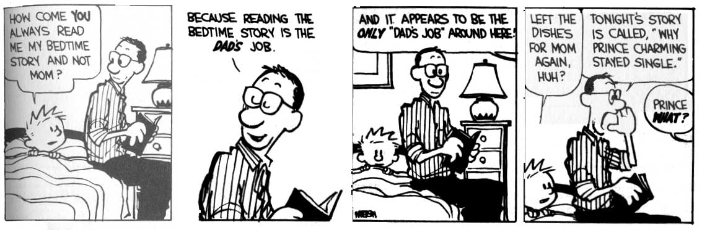

- Protestants have argued that Natural Law removes the need for God’s grace, as being good means following the rules, not being saved
- Many argue that there is no purpose in life; to support this argument, they point to tragedies such as the recent terrorism in New York, ‘acts of God’ such as floods or genetically inherited diseases and say that there is no designer behind the universe
- In some cases it seems cruel to follow a rule when the consequences are terrible; if we accept that it is occasionally alright to break Natural Laws then the whole theory is weakened.

Proportionalism
This position arises in response to the last criticism of Natural Law above. It argues that there are certain moral rules that should never be broken unless there is a proportionate reason to do so. It follows that an action can be bad (such as murder) but, under the circumstances, the right thing to do (murdering Hitler’s mother, for example).

In the Roman Catholic Church, euthanasia is strongly rejected. However, there may be occasions when proportionalism is used to justify not treating someone who is terminally ill. If the treatment being suggested results in a high level of pain without a great positive result, the pain is said to be disproportionate to the outcome and the treatment does not go ahead. Traditional Natural Law theory would not consider the outcome, and would base its decision on a rule such as ‘doctors should do everything in their power to save human life’.

Further Reading
Teach Yourself Ethics Mel Thompson, p41-54 (applied to infertility treatment & euthanasia p55-65)
Ethical Theory Mel Thompson, p58-65
The Puzzle of Ethics Peter Vardy & Paul Grosch, p36-52

