Utilitarianism
the greatest happiness for the greatest number

The Greatest Happiness Principle, stated above, is at the heart of a number of ethical theories that fall under the umbrella of ‘utilitarianism’. Utilitarianism is an incredibly useful, and increasingly popular, ethical position. Its many benefits are matched with some serious flaws. However, modern utilitarianists have repeatedly adapted the theory rather than discard it. Peter Singer is one example of a utilitarian whose ideas have gained great popularity in recent years.

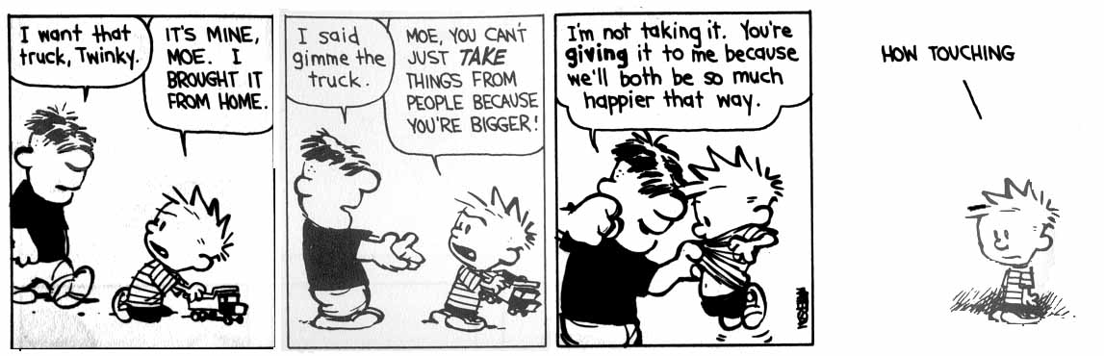

Jeremy Bentham (1748-1832)
Bentham equated happiness with pleasure and the absence of pain. His scientific mind led him to believe that the study of ethics could be undertaken in a practical way, carefully measuring the possible consequences or outcomes of an action before deciding which choice to take.

On the positive side, Bentham’s theories led to extensive social reform affecting Parliament, criminal law, the jury system, prisons, savings banks, cheap postage etc, etc. What was revolutionary about Bentham’s theory was that it resulted in all people being considered when making laws. His felicific calculus (also called the ‘hedonic’ or ‘utility’ calculus) was helpful in determining how to measure different amounts of pleasure:
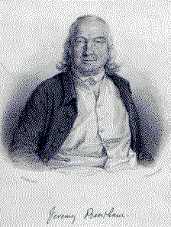
Remoteness – how near it is
Purity – how free from pain it is
Richness – to what extent it will lead to other pleasures
Intensity – how powerful it is
Certainty – how likely it is to result
Extent – how many people it affects
Duration – how long it lasts

There are some circumstances when you can usefully use the calculus as a guide to determining the overall effects of a course of action, such as in choosing how to spend lottery money, or in deciding how to prioritise medical procedures in a hospital. However, many of our moral decisions do not have predictable or measurable outcomes at all. It is unclear what counts as pleasure or how to equate pleasure and pain.

There is also something instinctively wrong with judging the morality of an action by it’s outcome – a person motivated solely by greed might choose a course of action that happens to make the greatest number of people happy. Does this make him a good person? Even more concerning is the possibility of sadists whose pleasure at torturing others is so great that this in itself makes their actions good. The theory seems to support the exploitation and abuse of minority groups if it pleases the ruling majority.
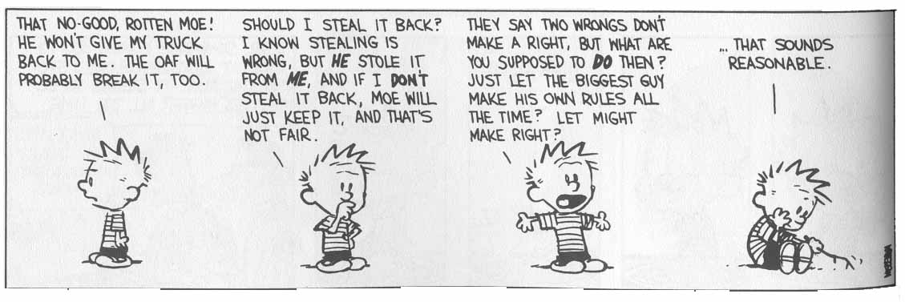
John Stuart Mill (1806-73)
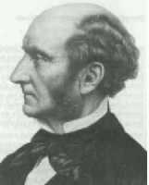
Mill believed that quality was more important than quantity when it came to pleasure. For example, the pleasures of the mind are far superior to the gratification of the body’s desires. This deals with the problem of sadistic torturers, as their pleasure is of a significantly lower kind.

‘It is better to be a human being dissatisfied than a pig satisfied; better to be Socrates dissatisfied than a fool satisfied.’

The problem is, how do you decide whether white-water rafting is a higher-level pleasure than listening to Beethoven played live or eating an Indian takeaway?

The theory seeks to reduce everything to a consideration of happiness, when moral decisions are actually a lot more complicated than that. It also still allows for great injustices to be carried out just as long as the greatest good is served. The theory went on to receive further modifications.

Act Utilitarianism
You look at an action to determine what is moral, and from this general rules can be derived. E.g. when faced with a road traffic accident (rta) a paramedic will treat a pregnant woman first. This is because in any given situation, the pregnant woman and her unborn child have a greater potential for future happiness than any individual involved in the crash. By deciding how to act in a specific case, the general rule ‘Always treat a pregnant woman first’ can be derived. This rule is only a guideline, and should be discarded if doing so will bring about more happiness (e.g. if a brain surgeon is in need of treatment)

The biggest criticism of Act Utilitarianism is that it is impossible to make the sorts of calculations it requires. On the plus side, it has most integrity, as it allows you to stick with the greatest happiness principle unswervingly – simply do whatever brings the most happiness in any given situation.

Rule Utilitarianism
Some general principles are formulated. From these, certain actions will be ruled out as unacceptable. The principle of utility is therefore applied to a rule, so the rule will hold if in general following it leads to greater happiness. This means that in an individual case, even though an injustice might bring about greater happiness, if it goes against the general principle that injustice tends to lead to misery and a reduction in happiness, it is deemed wrong.

Bentham is generally seen as an Act Utilitarian, as the Greatest Happiness Principle seems to demand, although Mill is associated with Rule Utilitarianism. As we saw, they are open to the criticism that utilitarianism goes against justice and human rights, as it allows abuses of rights if they bring enough happiness.

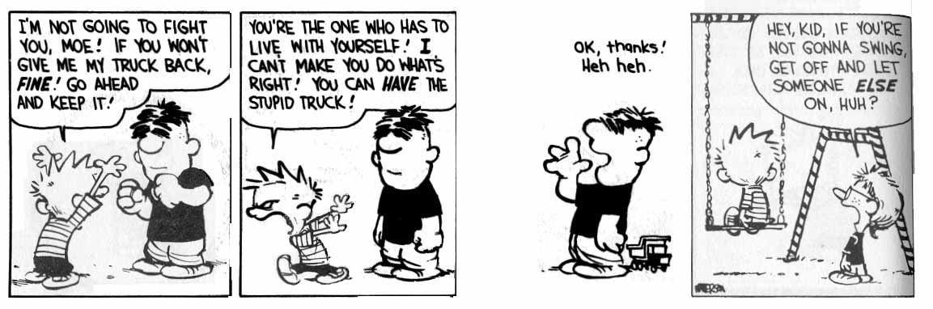

Preference Utilitarianism
Utilitarianism started out from the basic assumption by Bentham that man desires pleasure and seeks to avoid pain. This basic assumption can be challenged, as it seems to be wrong in at least some cases. People who wallow in self-pity seem to want to be in pain, and many people who have sinned or broken the law feel the need to be punished – they need to suffer in some way to put right what was wrong. Although it is possible to argue that in some long and complicated way the desire for punishment brings pleasure, it is easier and more satisfying to refine the utilitarian theory further. Rather than talk about pleasure and pain or happiness, some modern utilitarians look at the degree to which an action fulfils the preferences of others. This avoids making any judgement about the suitability of the desires of others or the ‘level’ of their happiness. It doesn’t avoid the problem of being incredibly difficult to calculate, though.

