Saviour Siblings
- Describe the process of creating a ‘Saviour Sibling’. Hints: IVF, PGD, check for inherited disorder, check for donor compatibility, implant, birth, umbilical cord, possible further medical procedures.
_______________________________________________________
_______________________________________________________
_____________________________________________________________________________________________
_____________________________________________________________________________________________
_____________________________________________________________________________________________
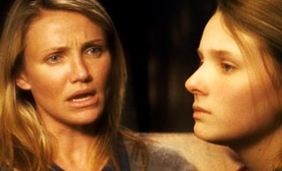
- Why do people use PGD to create a donor sibling instead of just having a child the natural way?
_________________________________________________________
_________________________________________________________
_________________________________________________________
- Make a list of arguments for and against allowing the use of PGD to create donor siblings.
For | Against

- “Christians should be against allowing donor siblings.” Do you agree? Give reasons on both sides before stating your conclusion.
_____________________________________________________________________________________________
_____________________________________________________________________________________________
_____________________________________________________________________________________________
_____________________________________________________________________________________________
_____________________________________________________________________________________________

