Therapeutic Cloning
- Describe how therapeutic cloning works. Hints: Donor egg, remove nucleus, cell removed from patient, patient’s nucleus -> egg, ‘shock’, embryonic stem cells used
_____________________________________________________________
_____________________________________________________________
______________________________________________________________________________________________
______________________________________________________________________________________________
- How would Judson (‘How to build a human’) benefit from therapeutic cloning?
______________________________________________________________________________________________
______________________________________________________________________________________________
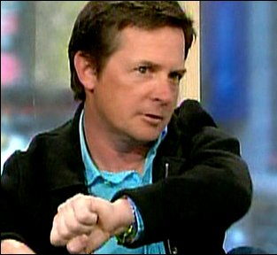
- Why does Michael J Fox support embryonic stem cell research?
________________________________________________________________________
________________________________________________________________________
- More than 100 million people could benefit from therapeutic cloning. List the types of treatment or procedure it could lead to.
________________________________________________________________________
______________________________________________________________________________________________
______________________________________________________________________________________________
- Why do some people think that therapeutic cloning is wrong? Give at least two of their reasons.
______________________________________________________________________________________________
______________________________________________________________________________________________
______________________________________________________________________________________________
______________________________________________________________________________________________
- “Christians should support therapeutic cloning.” Do you agree? Give reasons on both sides before stating your conclusion.
_____________________________________________________________________________________________
_____________________________________________________________________________________________
_____________________________________________________________________________________________
_____________________________________________________________________________________________
_____________________________________________________________________________________________

