SHABBAT SYMBOLS

White tablecloth | Purity
2 loaves of bread | Double portion of manna in the wilderness | 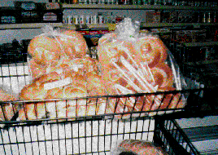
Plaited loaves | God – Israel – Torah | 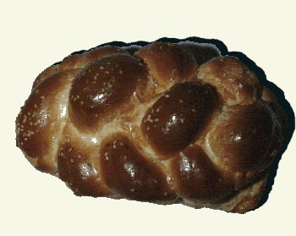
Salt on bread | Greatest hospitality
Candlight | It is different to electric light. At the beginning of Shabbat, this symolises peace coming into the house. | 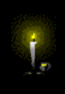
Shabbat itself | Covenant (agreement) between God and his people.
Hallah cover | Dew over the manna. To protect the bread’s sensitivities. To dress it like a bride. | 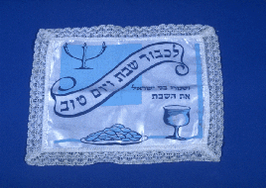
Best cutlery and crockery | Shabbat = Queen or Bride
2 candles | Creation of the world (life); Exodus (freedom).  Past and Future.
2 candles/loaves | Two different commandments – Remember Ex 20 and Observe Deut 5 the Sabbath Day.  Number of parents in an ideal family.
2 candles | Extra brightness of Shabbat.  Double soul (“extra” soul) on Shabbat.
Spices/spice box | Sweetness of Shabbat. To refresh the soul and bring peace and quiet at the start of a new week. | 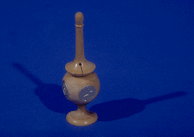
Covering the knife | Knife is a weapon of war and violence. Shabbat is a time of peace and harmony.
Plaited candle | God’s presence and the divine potential in every human being. | 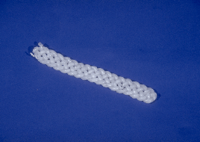

Covering the knife
2 candles/loaves

