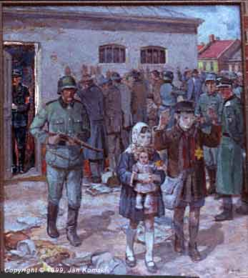
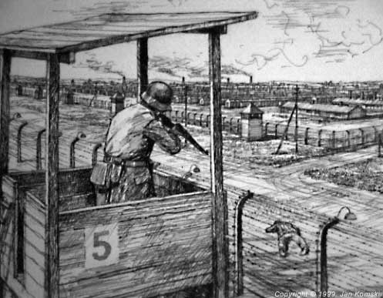
THE HOLOCAUST - Year 9 RS

Jews in Europe in the 1930s | Self | Peer | Tchr
I can list ways in which the Jews in Nazi Germany were treated differently in the 1930s
I can use several examples to show how being Jewish affected the way people were treated in Europe in the 1930s
I can give detailed examples of the prejudice and discrimination suffered by Jews in Europe in the 1930s
I can describe the situation for Jews in Europe in the 1930s and comment upon how it might have felt to be Jewish

Responses to the Holocaust | Self | Peer | Tchr
I can describe at least two different ways in which the Jews have responded to the Holocaust
I can give simple explanations of how both Jews and Christians have responded to the Holocaust
I can give clear explanations of a variety of different responses to the Holocaust from both Jews and Christians
I can show that I understand the variety of responses to the Holocaust and the way that these have developed

Language for Learning | Self | Peer | Tchr
I know what prejudice, discrimination and Holocaust mean
I can use terms such as prejudice, discrimination, scapegoat, and Holocaust accurately
I can also use terms such as genocide, anti-Semitism and theodicy accurately
I can use all of the key terms in the Language for Learning list correctly

Moral questions | Self | Peer | Tchr
I can explain why a German leader might have defended what he did and how a religious person might have argued that the leader was wrong
I can discuss what was right and wrong about the Holocaust from at least two different viewpoints
I have begun to consider the moral/ethical questions raised by these events for people at the time and for today
I can ask my own questions about the moral issues raised by The Holocaust and have begun to try to answer them

My own thoughts | Self | Peer | Tchr
I can say what I think about what I have learnt from the Holocaust. I can also say what I think society has learnt from the Holocaust
I can give my own opinion on the events and on the ways in which people have reacted to them
I have reflected thoughtfully on the issues raised and made links with the previous unit on ‘Why do people suffer’?
I have begun to compare the events of the Holocaust with modern day genocides and to say what I think about how people have responded to them

